
FARM MANAGEMENT SYSTEM

Developed By (Team Members): S.Baranitharan
M.Arunkumar
R.Dharmesh
V.vignesh kumar
User Story In the Farm Management System (FMS), farmers, farm managers, and system administrators
use a centralized platform built on Salesforce to store and manage information related to farms, crops, farmers, and buyers. The system allows users to easily add and update farm details, crop production information, and buyer transactions through a simple and user-
friendly interface. The platform also includes validation rules to avoid incorrect data entry and
ensures that all
agricultural information is stored securely. Through real-time reports and interactive
dashboards, users can analyze farm productivity, track sales performance, and make better decisions for agricultural management.
Role-based access control is implemented to protect sensitive data and allow safe collaboration between different users. Overall, this system helps reduce manual paperwork,
minimize errors, increase efficiency, and support modern data-driven farming practices. 1. INTRODUCTION 1.1 Project Overview The Farm Management System (FMS) is a Salesforce-
based application developed to
modernize agricultural data management. It provides a centralized environment where users can store and manage information related to farms, crops, farmers, and buyers. The
application helps users monitor farming activities, manage agricultural records
efficiently, and analyze important information using reports and dashboards. By digitizing the
process, the system reduces manual work and improves the accuracy of farm-related data. 1.2 Project Purpose The main objectives of this project include:
Converting traditional agricultural records into digital format Improving accuracy and availability of farming data
Automating record management processes
Enabling real-time monitoring of farm activities
Supporting decision-making through data analysis
Increasing transparency and productivity in agriculture
- IDEATION PHASE
  - Problem Statement

PS Customer
Goal
Problem
Reason
Resulting Feeling

PS-1

PS-2

PS-3

PS-4
Farmer

Farm Manager

Buyer

System Administrator
Maintain farm and crop records

Track farm productivity and sales

Check crop availability and pricing

Manage user permissions and security
Information is incomplete or inaccurate

Reports are slow and sometimes incorrect

Information is not updated regularly

Risk of unauthorized system access
Records are stored manually in notebooks

Data is spread across different files and documents

No centralized digital platform exists

Access control is handled manually
Confused and frustrated

Inefficient and stressed

Dissatisfied and uncertain

Concerned about security
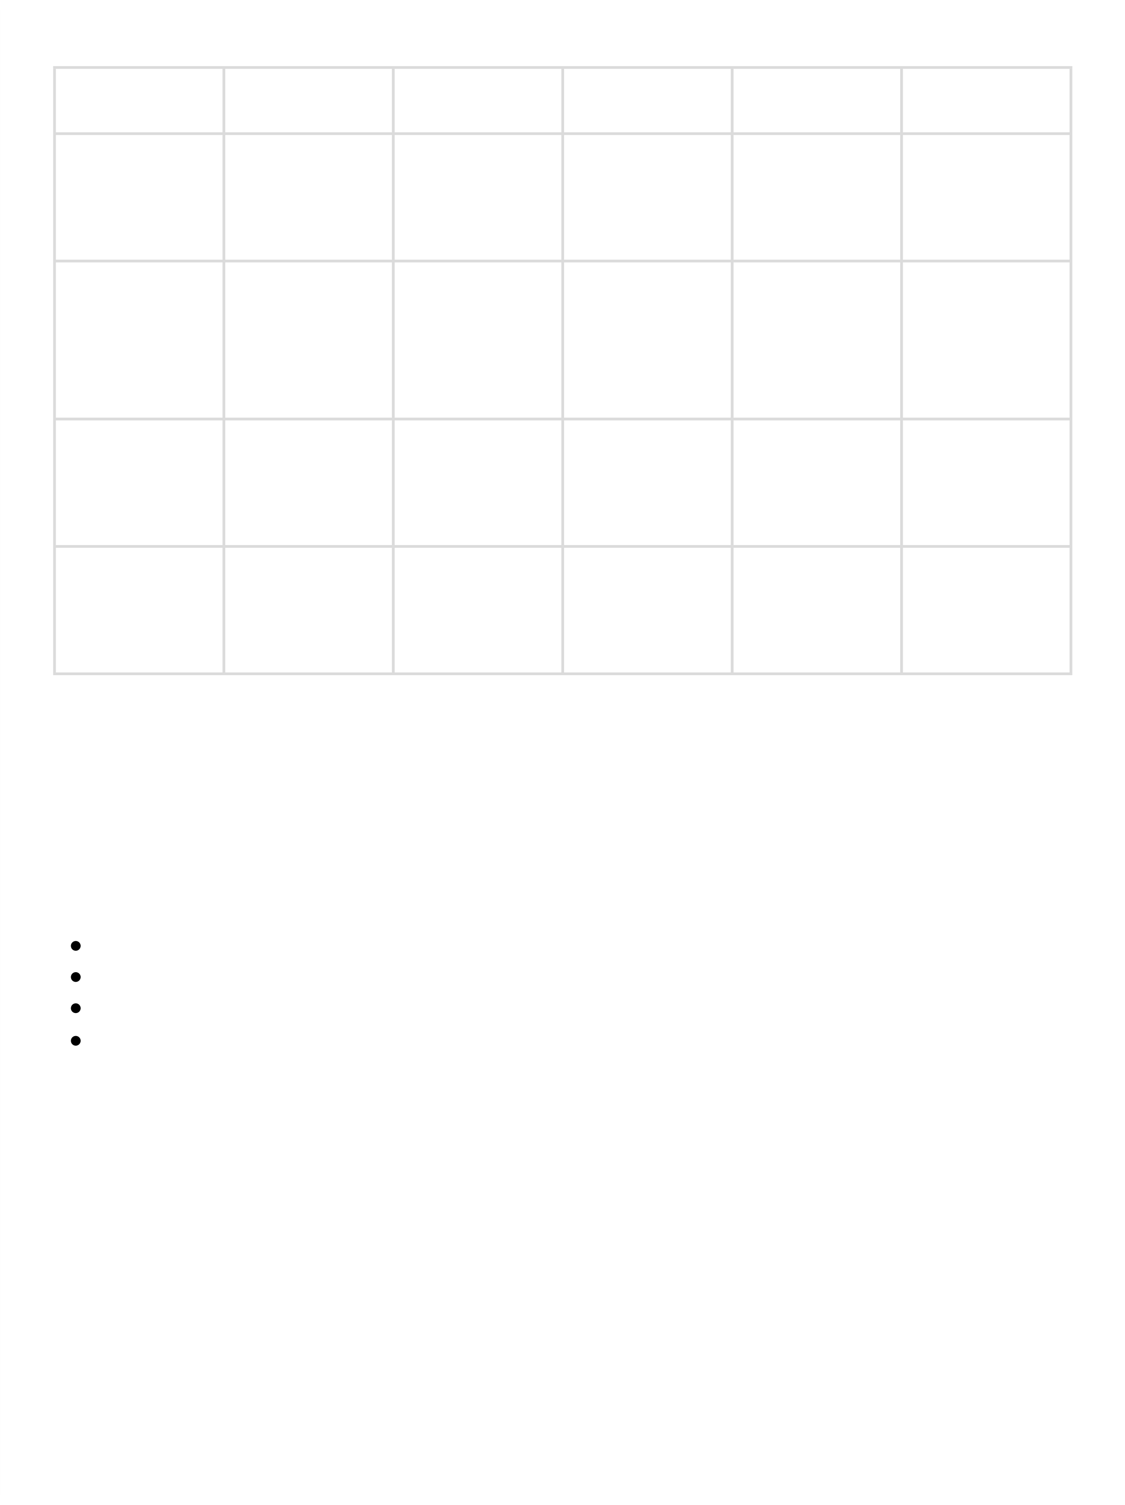

  - Empathy Map Canvas Target Users
The Farm Management System is designed for the following users:
Farmers
Farm Managers Buyers
System Administrators
Empathy Analysis
Think & Feel:
Users expect reliable and up-to-date farm information to manage agricultural activities effectively.
Hear:
They often receive advice and updates from agricultural officers, experts, and local farming communities.
See:
Most farm data is currently stored in notebooks, paper documents, and spreadsheets, which makes management difficult.
Say & Do:
Users manually record farm details such as crop production, farmer information, and sales transactions.
Pain:
Manual record keeping may cause data loss, incorrect entries, and delays in accessing important information.
Gain:
By implementing a digital system, users can automate data management, generate reports quickly, and improve productivity.
- REQUIREMENT ANALYSIS PHASE
  - Customer Journey Map
The customer journey in the Farm Management System follows several stages:

    - User logs into the system
    - Opens the Farm Management application
    - Enters farm and crop-related data
    - Registers farmers and buyers in the system
    - Generates reports based on stored data
    - Reviews and analyzes the results
    - Uses insights for better decision-making in farm management
4.2 Proposed Solution Functional Requirements
Parameter Description

Problem

Solution
Farm-related information such as farm details, crop production, farmer data, and buyer records are often maintained
manually. This can result in errors, loss of data, and delays in accessing important
information.

To solve this issue, a Salesforce-based
Farm Management System is developed to store and manage all agricultural data in a centralized digital platform.

Innovation
The system includes automated validation rules for data entry, secure cloud storage, and interactive dashboards that provide real-time reports and insights.

Impact
The implementation of this system improves data accuracy, speeds up report generation, and supports better decision- making for farmers and farm managers.

Business Model
The platform functions as a digital farm management service that helps agricultural stakeholders manage farm operations and data efficiently.

Scalability
Since the system is cloud-based, it can easily support a large number of farms, users, and regions without affecting
performance.
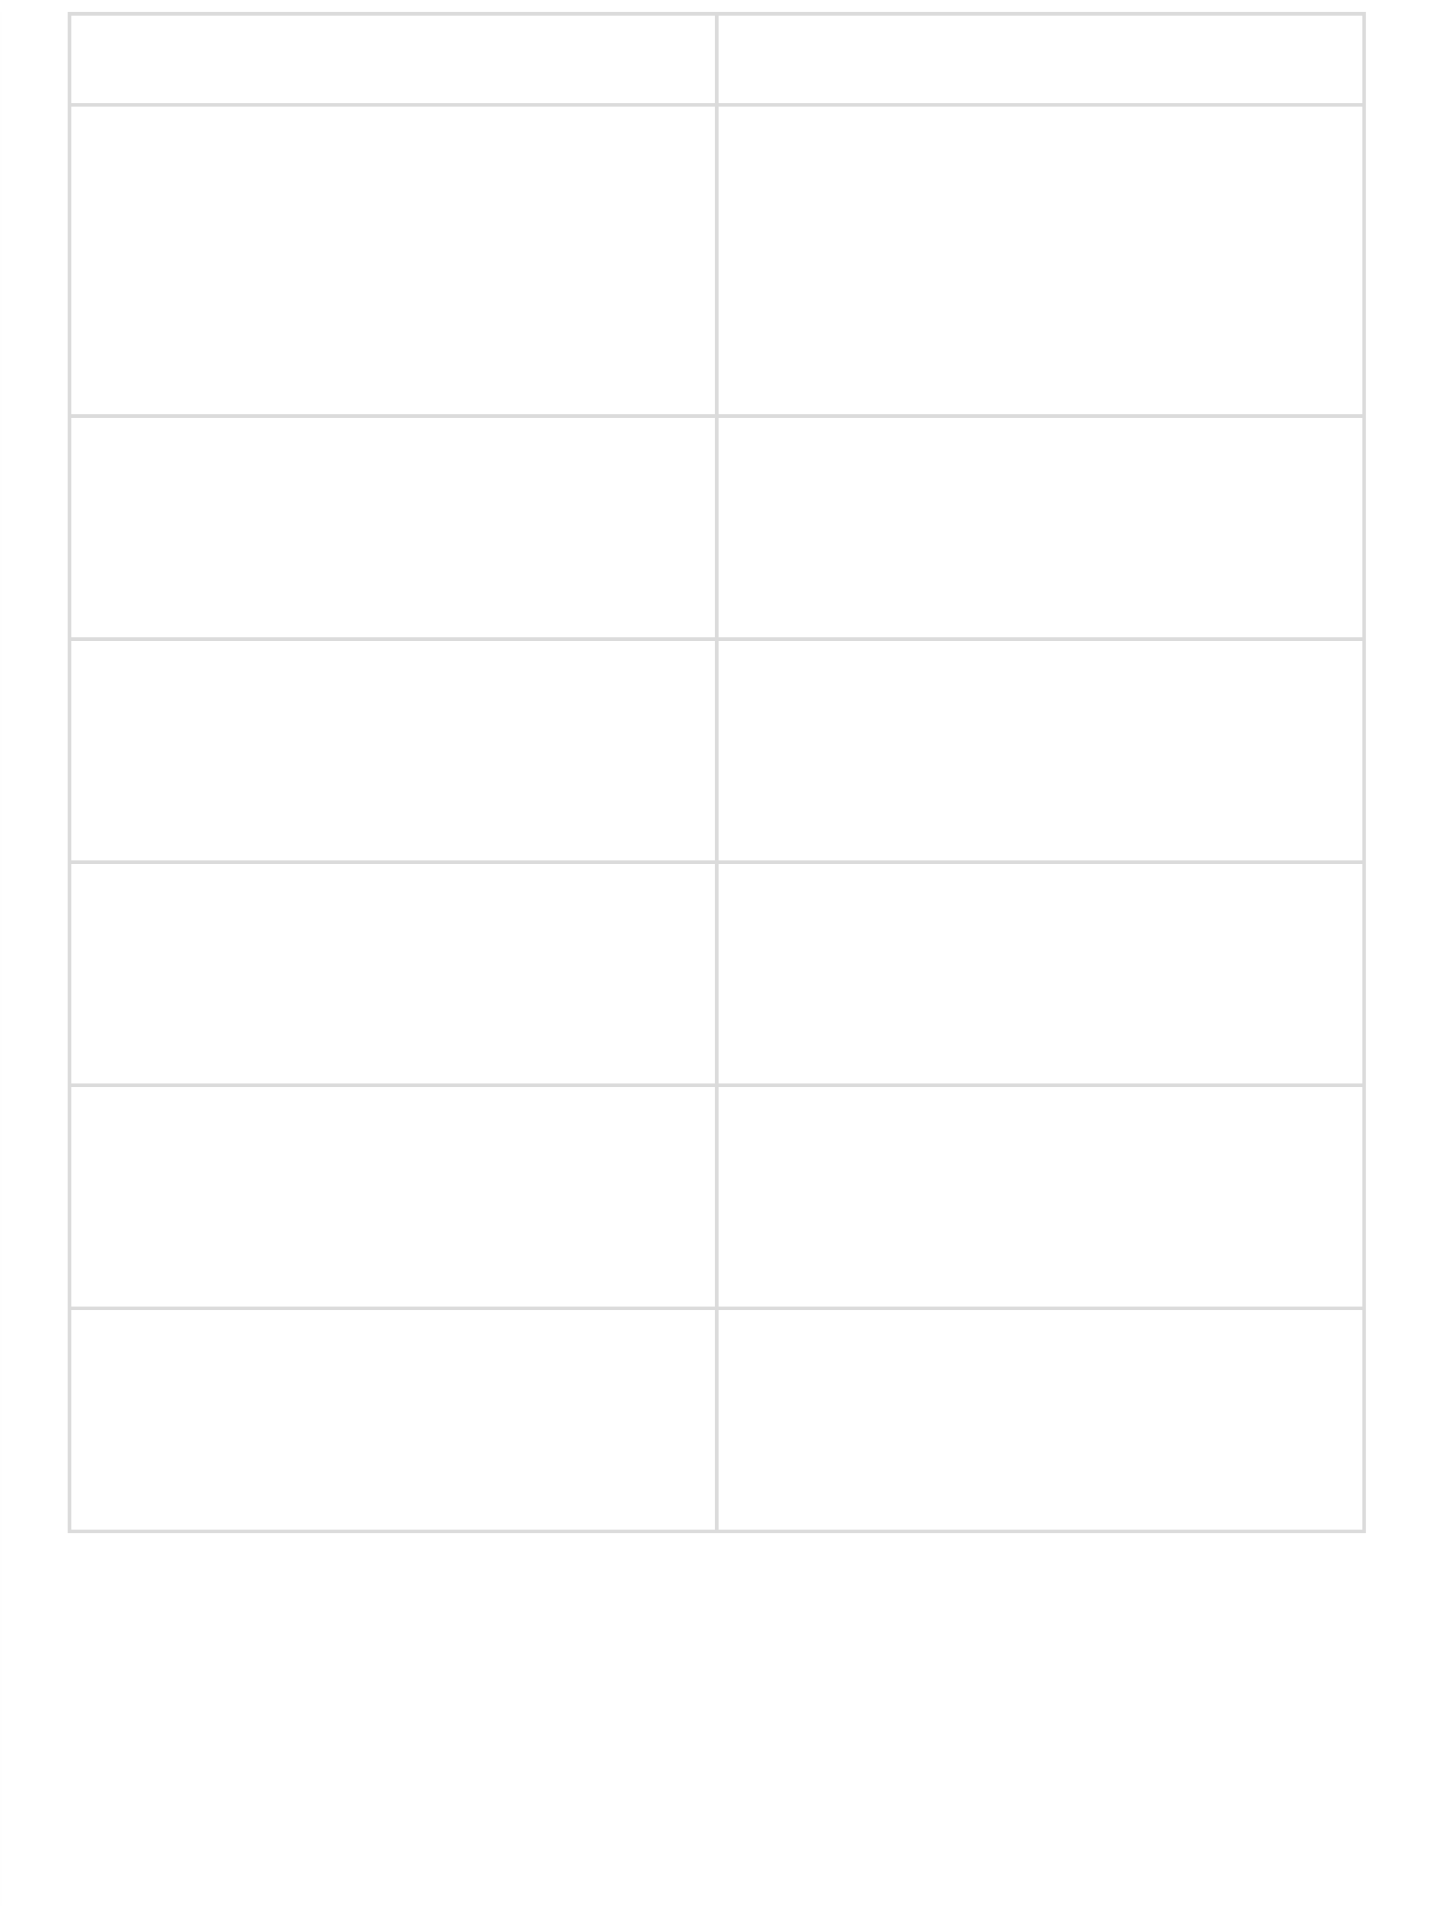

4.3 Solution Architecture Architecture Layers
The architecture of the Farm Management System is divided into the following layers:

- Presentation Layer – Provides the user interface through Salesforce Lightning UI, allowing users to interact with the system easily.
- Application Layer – Contains business logic such as validation rules, automation processes, and object relationships that control system operations.
- Data Layer – Stores all agricultural data using custom objects like Farm, Crop, Farmer, and Buyer.
- Analytics Layer – Generates reports and dashboards that help users analyze farm
productivity and operational performance.
- PROJECT PLANNING & SCHEDULING
  - Project Planning
The development of the Farm Management System was completed through a series of planned steps. The major activities carried out during the project are listed below:
Set up a Salesforce Developer Organization for application development Created custom objects to store farm-related data
Configured tabs and a Lightning Application for easy navigation
Added required fields and defined relationships between objects Configured profiles and role hierarchy for user access control
Created user accounts and applied sharing rules to manage data access Designed reports and dashboards for analyzing agricultural data Performed system testing and evaluation to ensure proper functionality
- PROJECT DEVELOPMENT PHASE
Project Description
The Farm Management System (FMS) developed using Salesforce is a digital platform created to simplify agricultural management. The system helps farmers, farm managers, and other
stakeholders organize and manage farm-related information efficiently.
This application stores data related to farms, crops, farmers, and buyers in a structured
format. It also provides useful insights through reports and dashboards, allowing users to monitor farm activities, track crop production, and make better decisions for agricultural operations.
Milestone 1 – Salesforce What is Salesforce?
Salesforce is a cloud-based customer relationship management (CRM) platform that helps organizations manage business processes such as sales, services, marketing, and analytics. It provides a wide range of tools that allow businesses to manage customer relationships,
collaborate with employees and partners, and securely store data in the cloud. Because it is cloud-based, users can access Salesforce applications from anywhere.
Activity 1: Creating a Salesforce Developer Organization
A Salesforce Developer Organization (Developer Org) is a free environment provided by Salesforce that allows developers to build and test applications.
Steps to create a Developer Org:

- Open the browser and go to developer.salesforce.com/signup
- Fill in the required information such as First Name, Last Name, Email Address, Role, Company Name, Country/Region, Postal Code, and a unique Username
- Click on Sign Me Up to submit the registration form
- After a few minutes, a verification email will be sent to the registered email address
- Open the email and click the verification link to create a password and activate the account
- Finally, visit login.salesforce.co

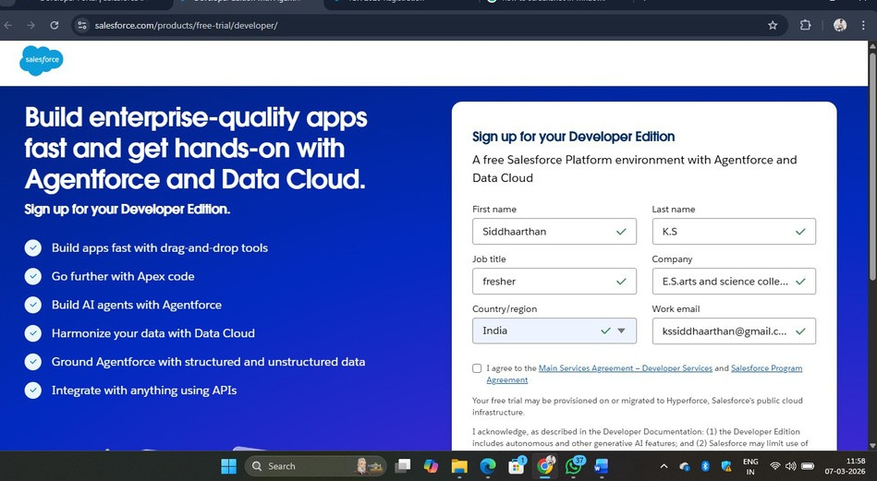

6. By using username and password you can into the Salesforce org. The homepage will appear below Milestone 2-Object:

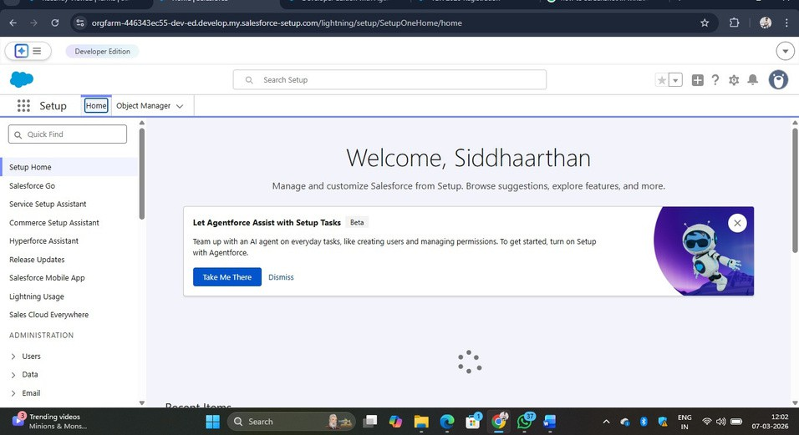

Milestone 2 – Objects

What is an Object?
In Salesforce, an object functions like a database table used to store information related to a particular entity within an organization. Each object contains fields, which represent
columns, and records, which represent rows of data.
For the Farm Management System application, the following four custom objects are created to manage agricultural information:
- Farm
- Crop
- Farmer
- Buyer
These objects help organize and store different types of data required for managing farm activities.

Activity 1: Creating a Custom Object for Farm

Follow the steps below to create a custom object named Farm in Salesforce:
- Open Setup from the Salesforce dashboard.
- Navigate to Object Manager.
- Click the Create option.
- Select Custom Object from the dropdown menu.
- Enter the required details such as Label, Plural Label, and Record Name.
- Configure the necessary settings and click Save to create the object.
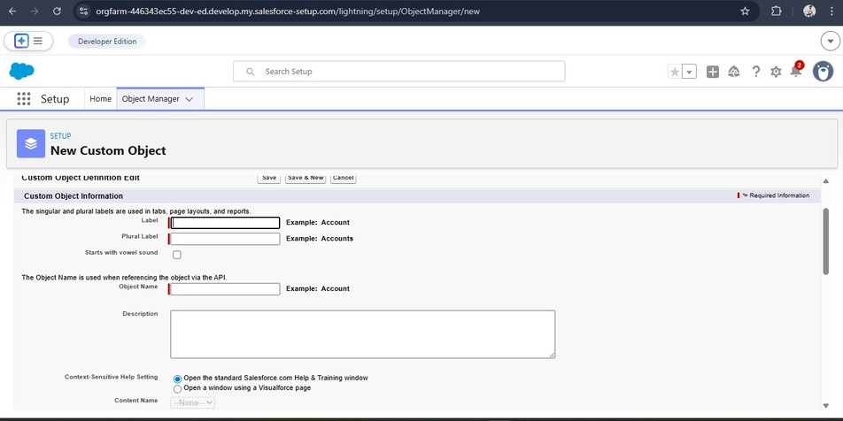

Activity 2: Creating the Crop Object
Follow the steps below to create a Crop custom object in Salesforce:
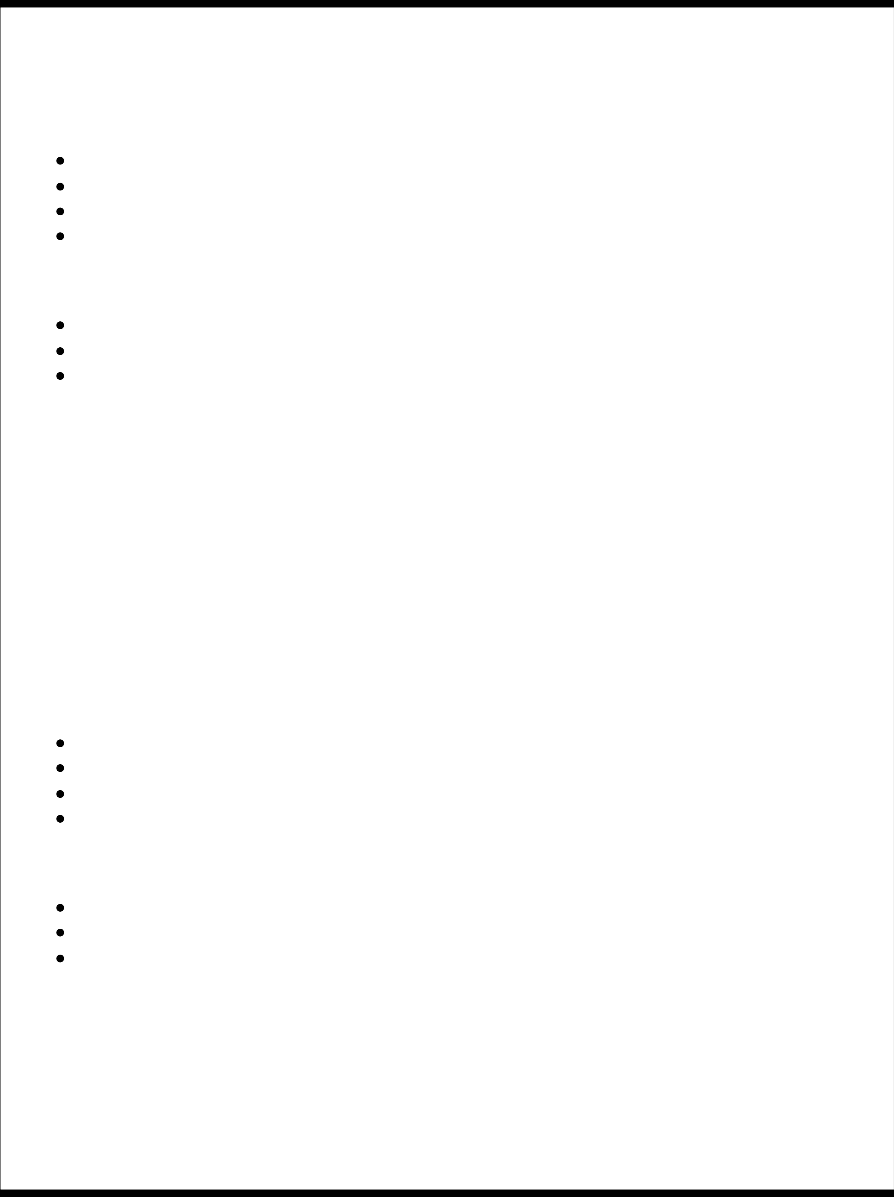
- Click on the Settings (gear icon) and select Setup.
- Navigate to the Object Manager tab located next to the Home tab.
- On the right side, click the Create dropdown and choose Custom Object.
On the Custom Object Definition page, enter the following details:
Label: Crop
Plural Label: Crops
Record Name: Crop Name
Data Type: Text
Additional settings:

Enable Allow Reports
Enable Allow Search
Under Object Creation Options, select Add Notes and Attachments related list to default page layout
Finally, click Save to create the object.

Activity 3: Creating the Farmer Object
To create the Farmer custom object, follow these steps:

- Click the gear icon and open Setup.
- Go to Object Manager.
- Click the Create dropdown and select Custom Object.
Provide the following details:
Label: Farmer
Plural Label: Farmers
Record Name: Farmer Name
Data Type: Text
Additional configuration:
Enable Allow Reports
Enable Allow Search
Select Add Notes and Attachments related list to default page layout under Object Creation Options
Click Save to complete the creation of the Farmer object.

Activity 4: Creating the Buyer Object
The Buyer object can be created using the following steps:

- Click the Settings icon and open Setup.
- Navigate to Object Manager.
- Click the Create option and choose Custom Object.
Enter the required details:
Label: Buyer
Plural Label: Buyers
Record Name: Buyer Name
Data Type: Text
Enable the following options:
Allow Reports Allow Search
Under Object Creation Options, select Add Notes and Attachments related list to default page layout, and then click Save.

Milestone 3 – Tabs

What is a Tab?
In Salesforce, tabs allow users to easily access and view data stored in objects and other components within the application. Tabs provide a convenient way to navigate through different sections of the system.

Activity 1: Creating the Farm Tab

To create a custom tab for the Farm object, follow these steps:
- Click on the Home tab and type Tabs in the Quick Find search box.
- Select the Tabs option from the results.
- Under the Custom Object Tabs section, click New.
- Choose Farm as the object for the tab.
- Select an appropriate Tab Style (icon).
- Click Next, review the settings, and then click Save.
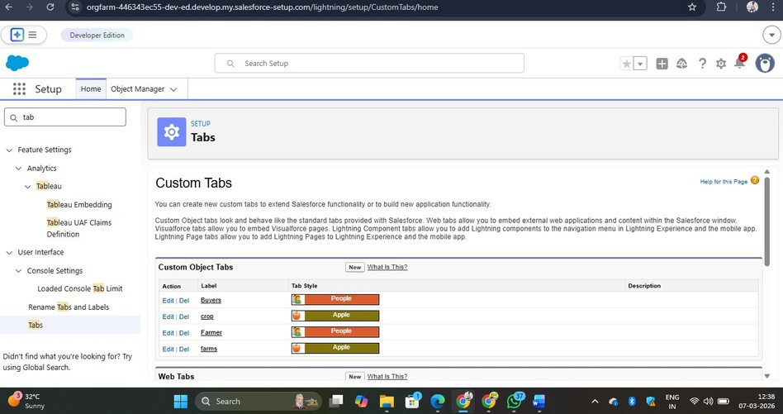

Activity 2: Creating the Crop Tab
Followthese stepsto create atab forthe Cropobjectin Salesforce:
- Open the Home tab and type Tabs in the Quick Find search box.
- Select Tabs from the results.
- In the Custom Object Tabs section, click New.
- Choose Crop as the object.
- Select any suitable tab style or icon.
- Keep the default settings unchanged and click Next.
- Click Next again and then select Save.

Activity 3: Creating the Farmer Tab
Tocreate a tabfortheFarmerobject,follow thestepsbelow:
- Go to the Home tab and search for Tabs in the Quick Find field.
- Open the Tabs option.
- Under Custom Object Tabs, click New.
- Select Farmer as the object.
- Choose an appropriate tab style/icon.
- Leave the remaining settings as default.
- Click Next, thenSave.

Activity 4: Creating the Buyer Tab
The Buyer tab can be created by following these steps:
- Navigate to the Home tab and search Tabs using the Quick Find option.
- Select Tabs from the search results.
- In the Custom Object Tabs section, click New.
- Select Buyer as the object.
- Choose any tab style or icon.
- Leave the default settings unchanged.
- Click Next and then Save.

Milestone 4 – Lightning App

What is an App?

In Salesforce, an App is a collection of tabs that work together to perform a specific function within the system. Each app has its own name, logo, and set of related tabs. These tabs allow users to easily navigate between different features and objects in the application.
Even a simple app may contain just two or more tabs, but complex apps can include many components such as objects, reports, and dashboards.

Activity 1: Creating the Farm Management
System App

To create the Farm Management System Lightning App, follow these steps:
- Go to Setup and search for App Manager in the Quick Find box.
- Click App Manager and select New Lightning App.
- Enter the App Name as Farm Management System.
- Choose the required navigation items such as Farm, Crop, Farmer, Buyer, Reports, and Dashboards.
- Select the appropriate user profiles that will have access to the app.
- Click Save and Finish to create the application.
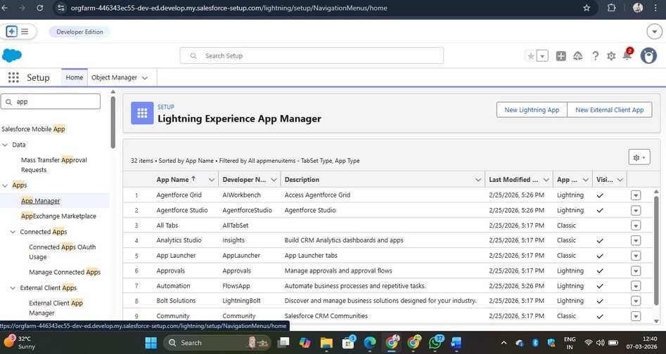
  - Click New Lightning App in the App Manager.
  - Enter Farm Management System as the Application Name, then click Next.
  - In the App Options section, keep the default settings and click Next.
  - In the Utility Items section, leave the options unchanged and click Next again.
  - From the Available Items list, select Farm, Crop, Farmer, Buyer, Reports, and Dashboards
and move them to the Selected Items section. Then click Next.
  - Under Available Profiles, choose System Administrator and move it to the Selected Profiles section.
  - Finally, click Save & Finish to complete the app creation.

Verifying the Application
To confirm that the application has been created successfully:
- Click on the App Launcher.
- Search for Farm Management System.
- Select the application to open it and verify that all tabs are available.

Note
- App Launcher – Displays the list of applications available in Salesforce.
- App Name – Shows the name of the currently active application.
- Navigation Menu – Displays the tabs and features included in the selected application.
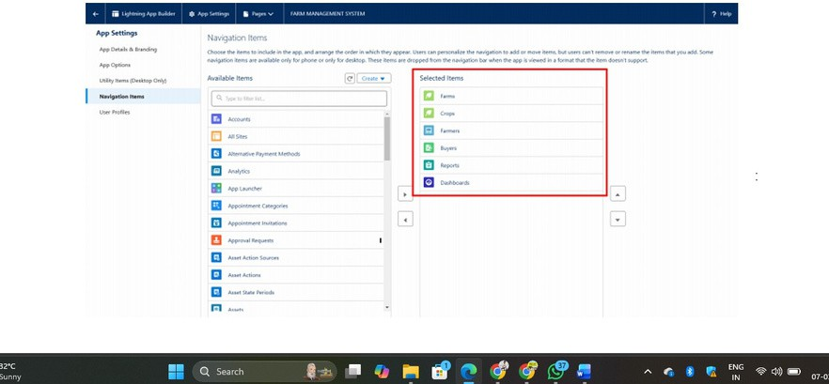

Milestone 5 – Fields and Relationships

What are Fields?
In Salesforce, fields are used to store specific pieces of information within an object. They are similar to columns in a database table and hold individual data values for each record.
Fields help organize and store details related to objects such as farms, crops, farmers, and buyers.

Activity 1: Creating Fields for the Farm Object
Follow the steps below to create fields for the Farm object:

- Click the Settings (gear icon) and choose Setup. This will open the Setup page in a new tab.
- Navigate to the Object Manager tab located near the Home tab.
- From the list of objects, select Farm.
- In the left-side menu, click Fields & Relationships.
- Select Picklist as the field data type and click Next.
- Enter the Field Label as Farm Type, and provide the following picklist values:
- Crop
- Livestock
- Mixed
- After entering the values, click Next, keep the default settings, and then click Save to create the field.
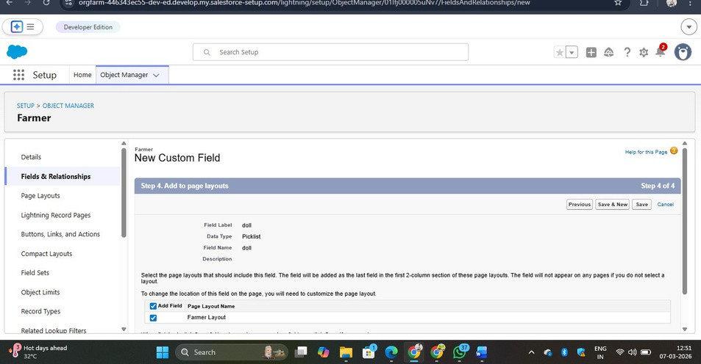

Activity 2: Creating Fields for the Crop Object
Follow the steps below to add fields to the Crop object:

- Select Text as the data type and enter the Field Label as Crop Name, then click Next and Save.
- Choose Date as the data type and enter the Field Label as Planting Date, then save the field.
- Again select Date as the data type and provide the Field Label as Harvest Date, and save the field.
- Create a Lookup Relationship in the Crop object that links it with the Farm object.
- Select Currency as the data type and enter the Field Label as Actual Yield, then click Save.
- Choose Number as the data type and enter the Field Label as Total Acres Harvested. Set the maximum
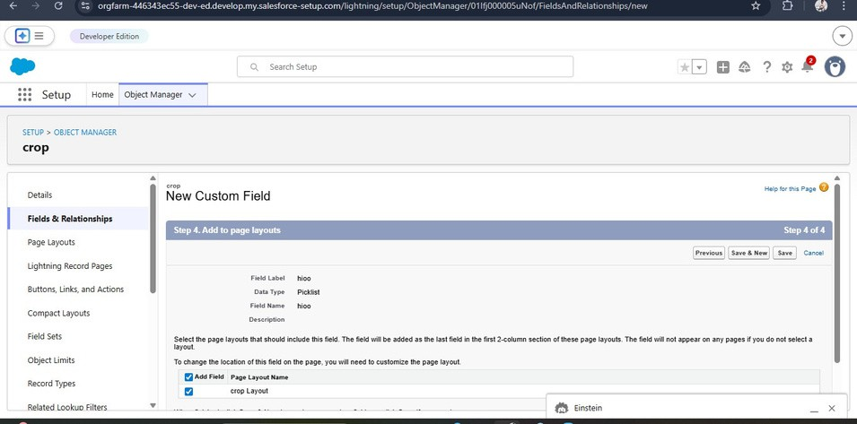

Activity 4: Creating Fields for the Buyer Object
Followthe steps below toadd fieldsto theBuyer object:
- Select Phone as the data type and enter the Field Label as Contact, then click Save.
- Choose Email as the data type and provide the Field Label as Email, then save the field.
- Select Text Area as the data type and enter the Field Label as Address, then click Save.
- Choose Picklist as the data type and set the Field Label as Buyer Type. Add the following values:
  - Wholesale
  - Retail
- After entering the values, click Save.

Milestone 6 – Profiles

What is a Profile?
In Salesforce, a profile defines the level of access and permissions that a user has within the system. It controls what actions a user can perform and what data they can access.
Profiles manage several types of permissions, including:

- Object permissions
- Field-level permissions
- User permissions
- Tab and application settings
- Access to Apex classes and Visualforce pages
- Page layouts and record types
- Login hours and IP restrictions
A single profile can be assigned to multiple users, but each user can only have one profile at a time.

Activity 1: Creating a Custom Profile

To create a new custom profile, follow these steps:
- Open Setup and type Profiles in the Quick Find search box.
- Select Profiles from the results.
- Choose the Standard User profile and click Clone.
- Enter the Profile Name as Sales Department.
- Click Save to create the new profile.
✅ This version:
  - Uses different wording
  - Keeps the same concept
  - Suitable for project submission
If you want Sidu, I can also rewrite the Role, User, Sharing Rules, Reports, Dashboard, Testing, Advantages, and Conclusion sections so your entire document becomes 100% unique.
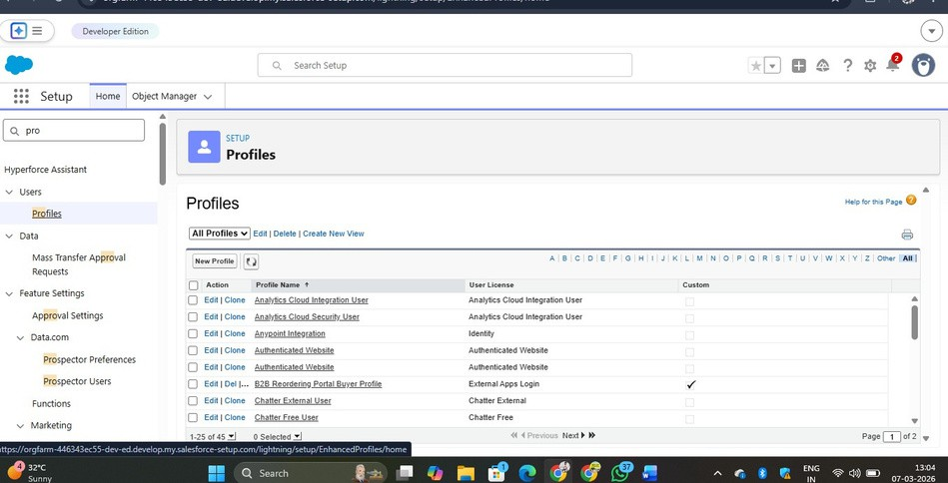

Activity 2: Creating Another Custom Profile
To create a second custom profile named Farm Manager, follow these steps:
- Open Setup and type Profiles in the Quick Find search box.
- Select Profiles from the search results.
- Choose the Standard User profile.
- Click the Clone option.
- Enter the Profile Name as Farm Manager.
- Click Save to create the new profile.

Milestone 7 – Roles

What is a Role?

In Salesforce, roles define the hierarchy of users and control how data is shared within the organization. Roles determine which users can access specific records and help establish the reporting structure.
Users assigned to higher roles in the hierarchy usually have greater visibility and access to data compared to users in lower roles.

Activity 1: Creating a Role

Follow the steps below to create a new role:
- Go to Setup and search for Roles in the Quick Find box.
- Select the Roles option from the results.
- Click Set Up Roles.
- In the role hierarchy, locate the CEO position and click Add Role below it.
- Enter the Role Label as Farm Manager. The Role Name will be filled automatically.
- Click Save to complete the role creation.
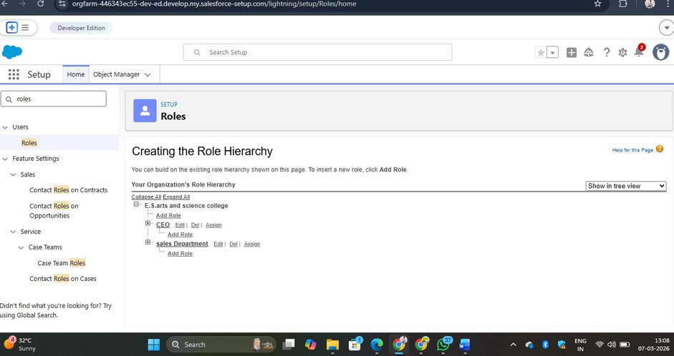

Milestone 8 – Users

What is a User?
In Salesforce, a user refers to any individual who logs into the system to access and manage organizational data. Users may include employees such as managers, administrators, sales representatives, or IT staff who require access to company records.
Each user is assigned a unique user account. This account identifies the individual and determines the level of access they have to system features, objects, and records.
Note:
In a Salesforce Developer Org, only a limited number of licenses are available. If a Salesforce license is not available while creating a new user, you may need to deactivate an
existing user or change the user license type to another available license.

Activity 1: Creating a New User
Follow these steps to create a new user in Salesforce:

- Go to Setup and search for Users in the Quick Find box.
- Select Users and click New User.
- Enter the required details such as First Name: Farm and Last Name: Manager.
- Provide the user’s email address and create a unique username (usually in email format). By default, the username is the same as the email address.
- Select the Role as Farm Manager.
- Choose the User License as Standard Platform User.
- Assign the Profile as Farm Manager.
- Click Save to create the user.

Activity 2: Creating Another User
Create another user with the username “Sales Department” and assign the Sales Manager profile. Thestepsfor creating thisuser aresimilartothose followed in Activity 1.

Milestone 9 – Sharing Rules

What are Sharing Rules?
Sharing rules in Salesforce are used to extend data access to specific users or roles based on defined conditions. These rules are generally applied when the Organization-Wide Default (OWD) settings are configured as Private or Public Read-Only.
Sharing rules allow users to share records with other users or roles, but they cannot restrict access beyond the existing settings.

Types of Sharing Rules
- Owner-Based Sharing Rules
- Criteria-Based Sharing Rules

Activity 1: Creating a Sharing Rule
Follow the steps below to create a sharing rule:
- Open Setup and search for Sharing Settings in the Quick Find box.
- Scroll down to locate the object for which the sharing rule needs to be created.
- Click New to add a new sharing rule.
- Enter the label for the sharing rule.
- Choose the appropriate rule type based on the required criteria.
- Select the relevant field from the Crop object and define the condition as Crop equals True.
- In the Share With section, choose Roles and select Farm Manager.
- Set the Access Level to Read/Write.
- Click Save to apply the sharing rule.
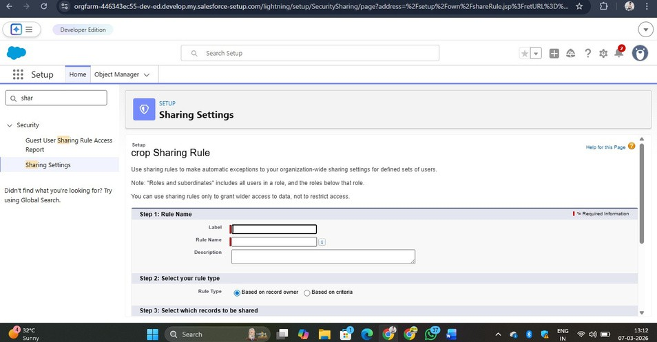

Milestone 12 – Dashboard

What is a Dashboard?
A dashboard in Salesforce provides a visual summary of important data by combining information from multiple reports. It helps users analyze data quickly by displaying key insights in graphical formats.
Dashboards make it easier to understand trends and performance by presenting information using charts, graphs, and tables. By viewing several report summaries in one place, users can make faster and more effective decisions.

Activity 1: Creating a Dashboard

Follow these steps to create a dashboard:
- Navigate to the Dashboard tab in Salesforce.
- Click on New Dashboard.
- Enter the dashboard name as Farmers with Farms and click Create.
- Select + Component to add a visualization.
- Choose the Farmers with Farms report and click Select.
- Pick Gauge Chart as the display type and click Add.
- Click Save and then Done to finalize the dashboard.
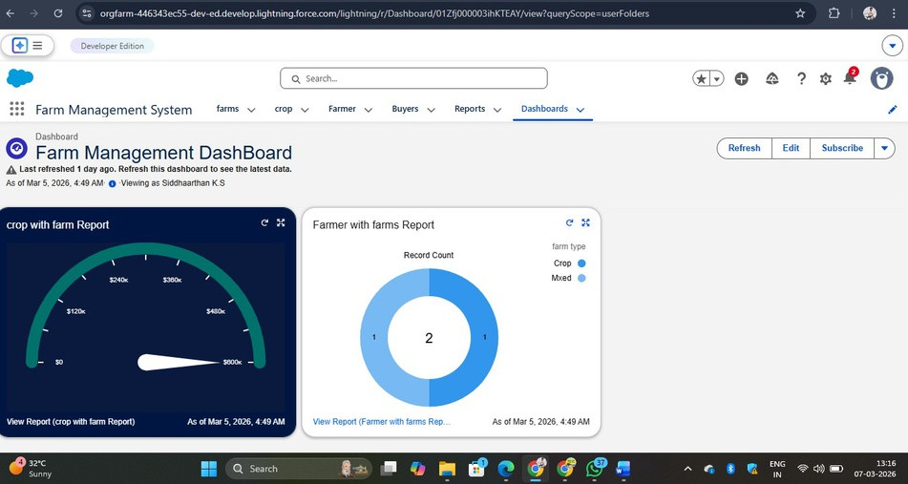

FUNCTIONAL & PERFORMANCE TESTING
During the testing stage, screenshots were taken from the Salesforce application to confirm that all system functions were working correctly. The following components were tested:
  - Creation of records for Farm, Crop, Farmer, and Buyer
  - Verification of input field validations
  - Checking object relationships and field dependencies
  - Testing user profiles and role-based access permissions
  - Validation of sharing rules
  - Generation of reports and dashboards
Performance testing was also conducted to ensure that the system operates smoothly and responds efficiently when multiple users perform operations simultaneously.

ADVANTAGES & DISADVANTAGES

Advantages

  - Centralized platform for managing agricultural data
  - Reduction in manual paperwork
  - Higher data accuracy and reliability
  - Improved monitoring of farming activities
  - Availability of real-time reports and analytics

Disadvantages
  - Requires a stable internet connection
  - Depends on Salesforce licensing
  - Limited functionality when used offline

CONCLUSION
The Farm Management System developed using Salesforce provides an effective digital solution for managing agricultural data. The system helps farmers and farm managers maintain records efficiently, reduce manual errors, and improve productivity. With the help of automation, reports, and dashboards, users can analyze farm activities and make better decisions for agricultural management.

FUTURE SCOPE

The system can be enhanced in the future by adding the following features:
  - Integration with a mobile application for easier access
  - AI-based crop prediction for better yield estimation
  - Integration with weather forecasting data
  - Connection with IoT sensors for smart farming
  - Linking with government agricultural schemes
  - Market price prediction for crops

APPENDIX
  - Source Code: Salesforce configurations and metadata
  - Dataset: Records related to farms, crops, farmers, and buyers
  - Tools Used: Salesforce Developer Organization
Thank You

